LEGACY GLOBAL SUMMIT 2020
Positioning Africa for profitable partnerships
November 5th & 6th 2020
Virtual Event
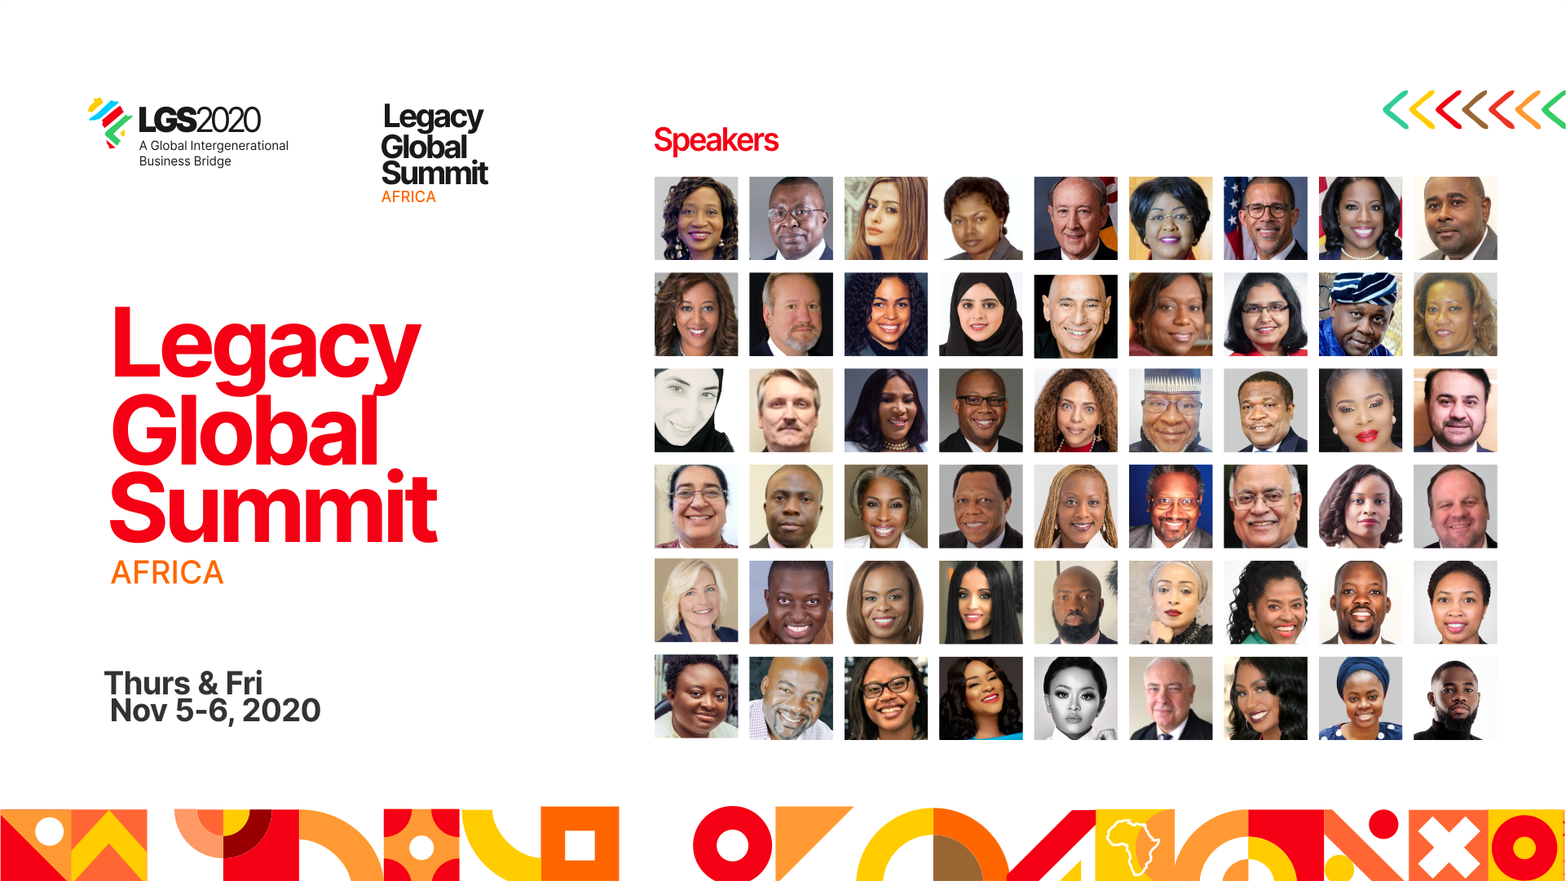

The premiere edition of the Legacy Global Summit organised by Legacy Premier Foundation held on the 5th & 6th of November 2020. The virtual event hosted business leaders, investors, educators and distinguished men and women from different sectors and works of life as they shared practical insights on several topics.
The conference, through panel discussions and plenary sessions, focused on nurturing and strengthening long term business relationships between US and Africa, opening up channels of sustainable business opportunities, supporting growing African businesses, fostering mutual business interests, and building a formidable ecosystem of trade and investment, that will enhance ease of doing business between the United States and Africa.
Day 1, Thursday 5th Nov. 2020
The event kicked off with the opening remark by Dr. Remi Duyile, Founder of the Legacy Premier Foundation and the convener of the conference. She stated the importance of intergenerational collaboration and partnership and how the future of Africa must be preserved. She spoke about her faith in the future of Africa and highlighted the possibilities of greater outcomes as regards to trade and investment in Africa.
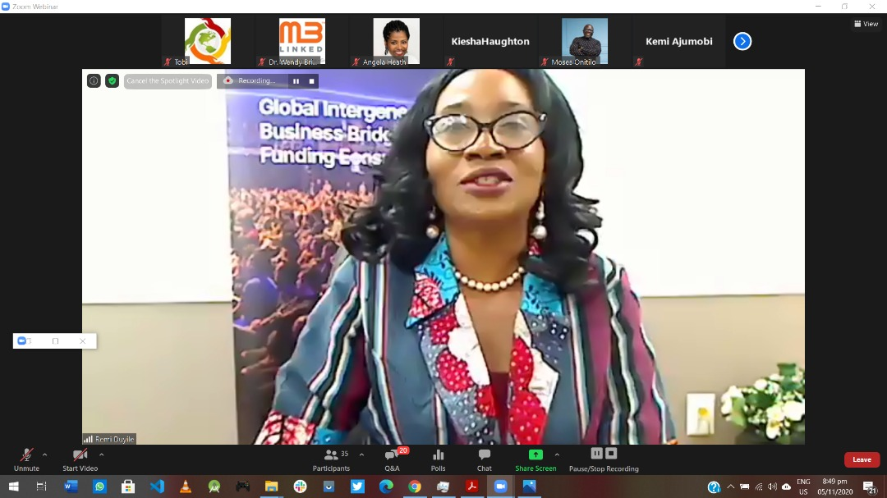
Dr. Remi Duyile

Special remarks to the six continent participants was followed by John C. Wobensmith, Secretary of State of Maryland , USA
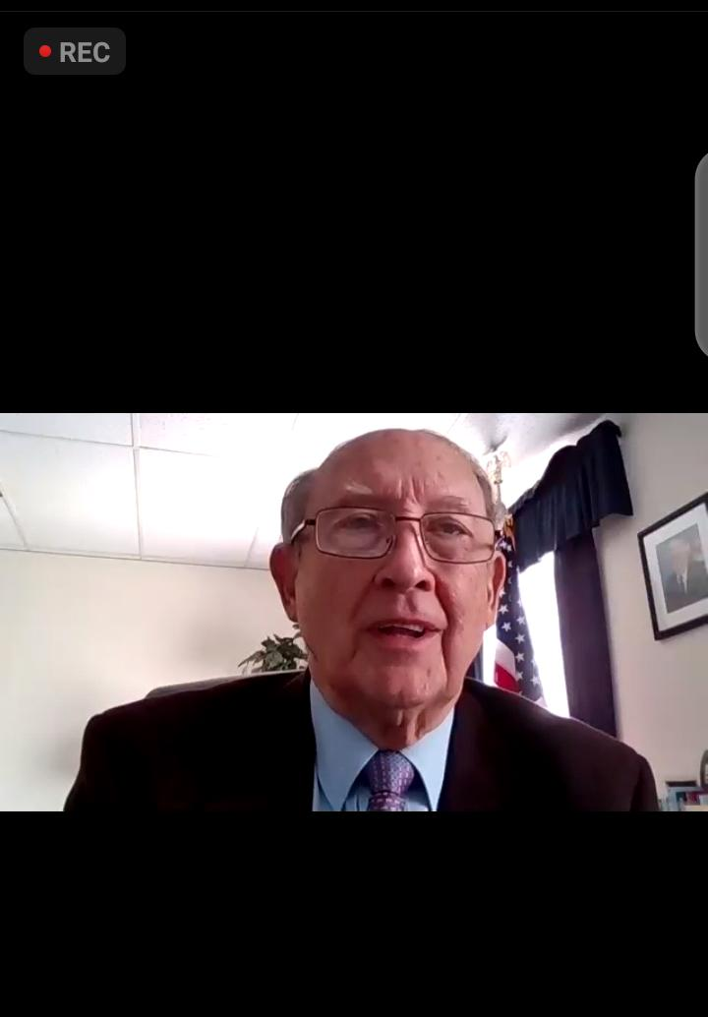
John C. Wobensmith

The opening remark was followed with a brief orientation of the virtual teleconferencing platform by Dr Wendy Brisley Executive Director of M3Linked , and a SUPER networking session by Dr. Richard Kaye from CEO space International.

Brian Castleberry, the Regional Manager - Middle East, Africa & India Office of International Investment and Trade moderated the first panel session titled "Doing Business In The UAE" which had business personalities from Dubai - Sheikha Abdulla AlNuaimi, Executive Director of Marketing and Sales Ajman Free Trade Zone UAE and Arshi Zaveri, CEO TrustwithTrade Group as panelists.
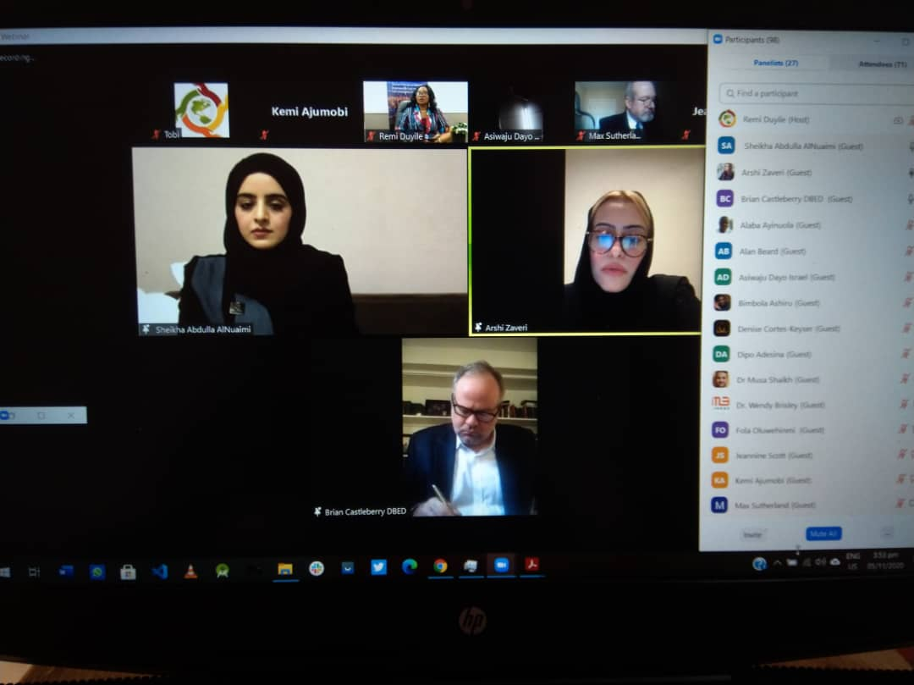
L-R: Skeiha Abdulla AlNuaimi, Arshi Zaveri and Brian Castleberry

They highlighted the possibilities of doing business in the UAE and also mentioned that there are no barriers to foreign investments from diverse sectors. Sheikha Abdulla AlNuaimi pointed out that the creation of the free trade zone has become one of the biggest drivers for business growth in the UAE. In response to the question of gender inclusion in the business community of the UAE, Arshi Zaveri stated that the leadership of the UAE has ensured that women-owned businesses are supported and women are welcomed even in executive positions.
The second panel session 'Access to capital' was moderated by Jeannine Scott, the Founder and Principal of America to Africa Consulting, LLC (A2A). The panelists were: Alan Beard, Roshanda Johnson - Business Development Specialist US International Development Finance Corporation Brian Castleberry, Nicole Woods - Business Development Expert Export-Import Bank of the United States and Femi Akinrebiyo - Global Manager, Upstream manufacturing Agribusiness and services IFC
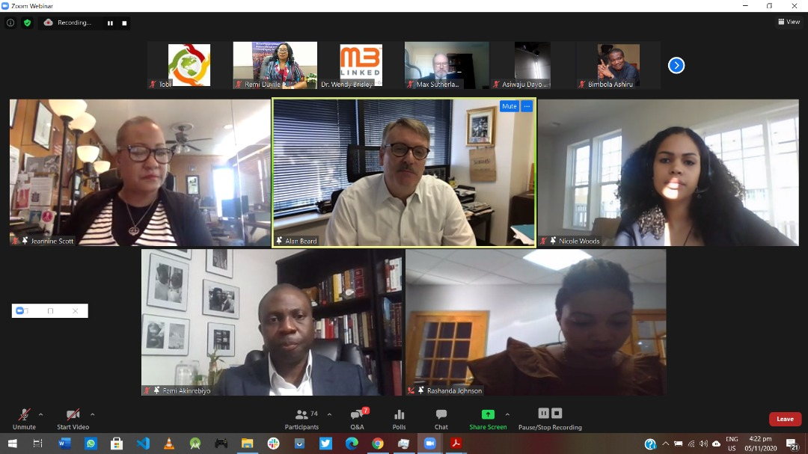
L-R: jeannine Scott, Alan Beard, Nicole Woods, Femi Akinrebiyo and Rashanda Johnson.

The discussion was centered around the issues faced by SMEs as regards getting capital for their business or projects.The essence of capacity building for business owners was also discussed in order for businesses to measure up to the requirements of financing institutions.
One of the panelists, Alan Beard, from Interlinks spoke about how important it is for business owners to have high quality financial statements before seeking capital.
Femi Akinrebiyo, global manager IFC enjoined entrepreneurs to know where to go in order to get capital or funds. He mentioned that every financial Institution has specifics, as regards what kind of idea or project they invest in.
Nicole Woods, a business development expert spoke about the role relationships and partnerships play in giving entrepreneurs access to real opportunities. She advised business owners to have a good plan and strategy before meeting with any investor or financial institution.
Rashanda Johnson from DFC stated the willingness of the dfc towards entrepreneurs to scale their business or project.
Jeannine Scott concluded by saying that the ability to be flexible and to move quickly is very important for business success.
The third panel, titled ‘Doing Business in Africa’ was moderated by the Chief Commercial Officer of Mixta Africa, Rolake Akinugbe-Filani. The panelists included: Dipo Adesina, Dr. Olawanle Akinboboye, Esther Dassanou, Hon. Idris Mohammad, and Gregory Simpkins.
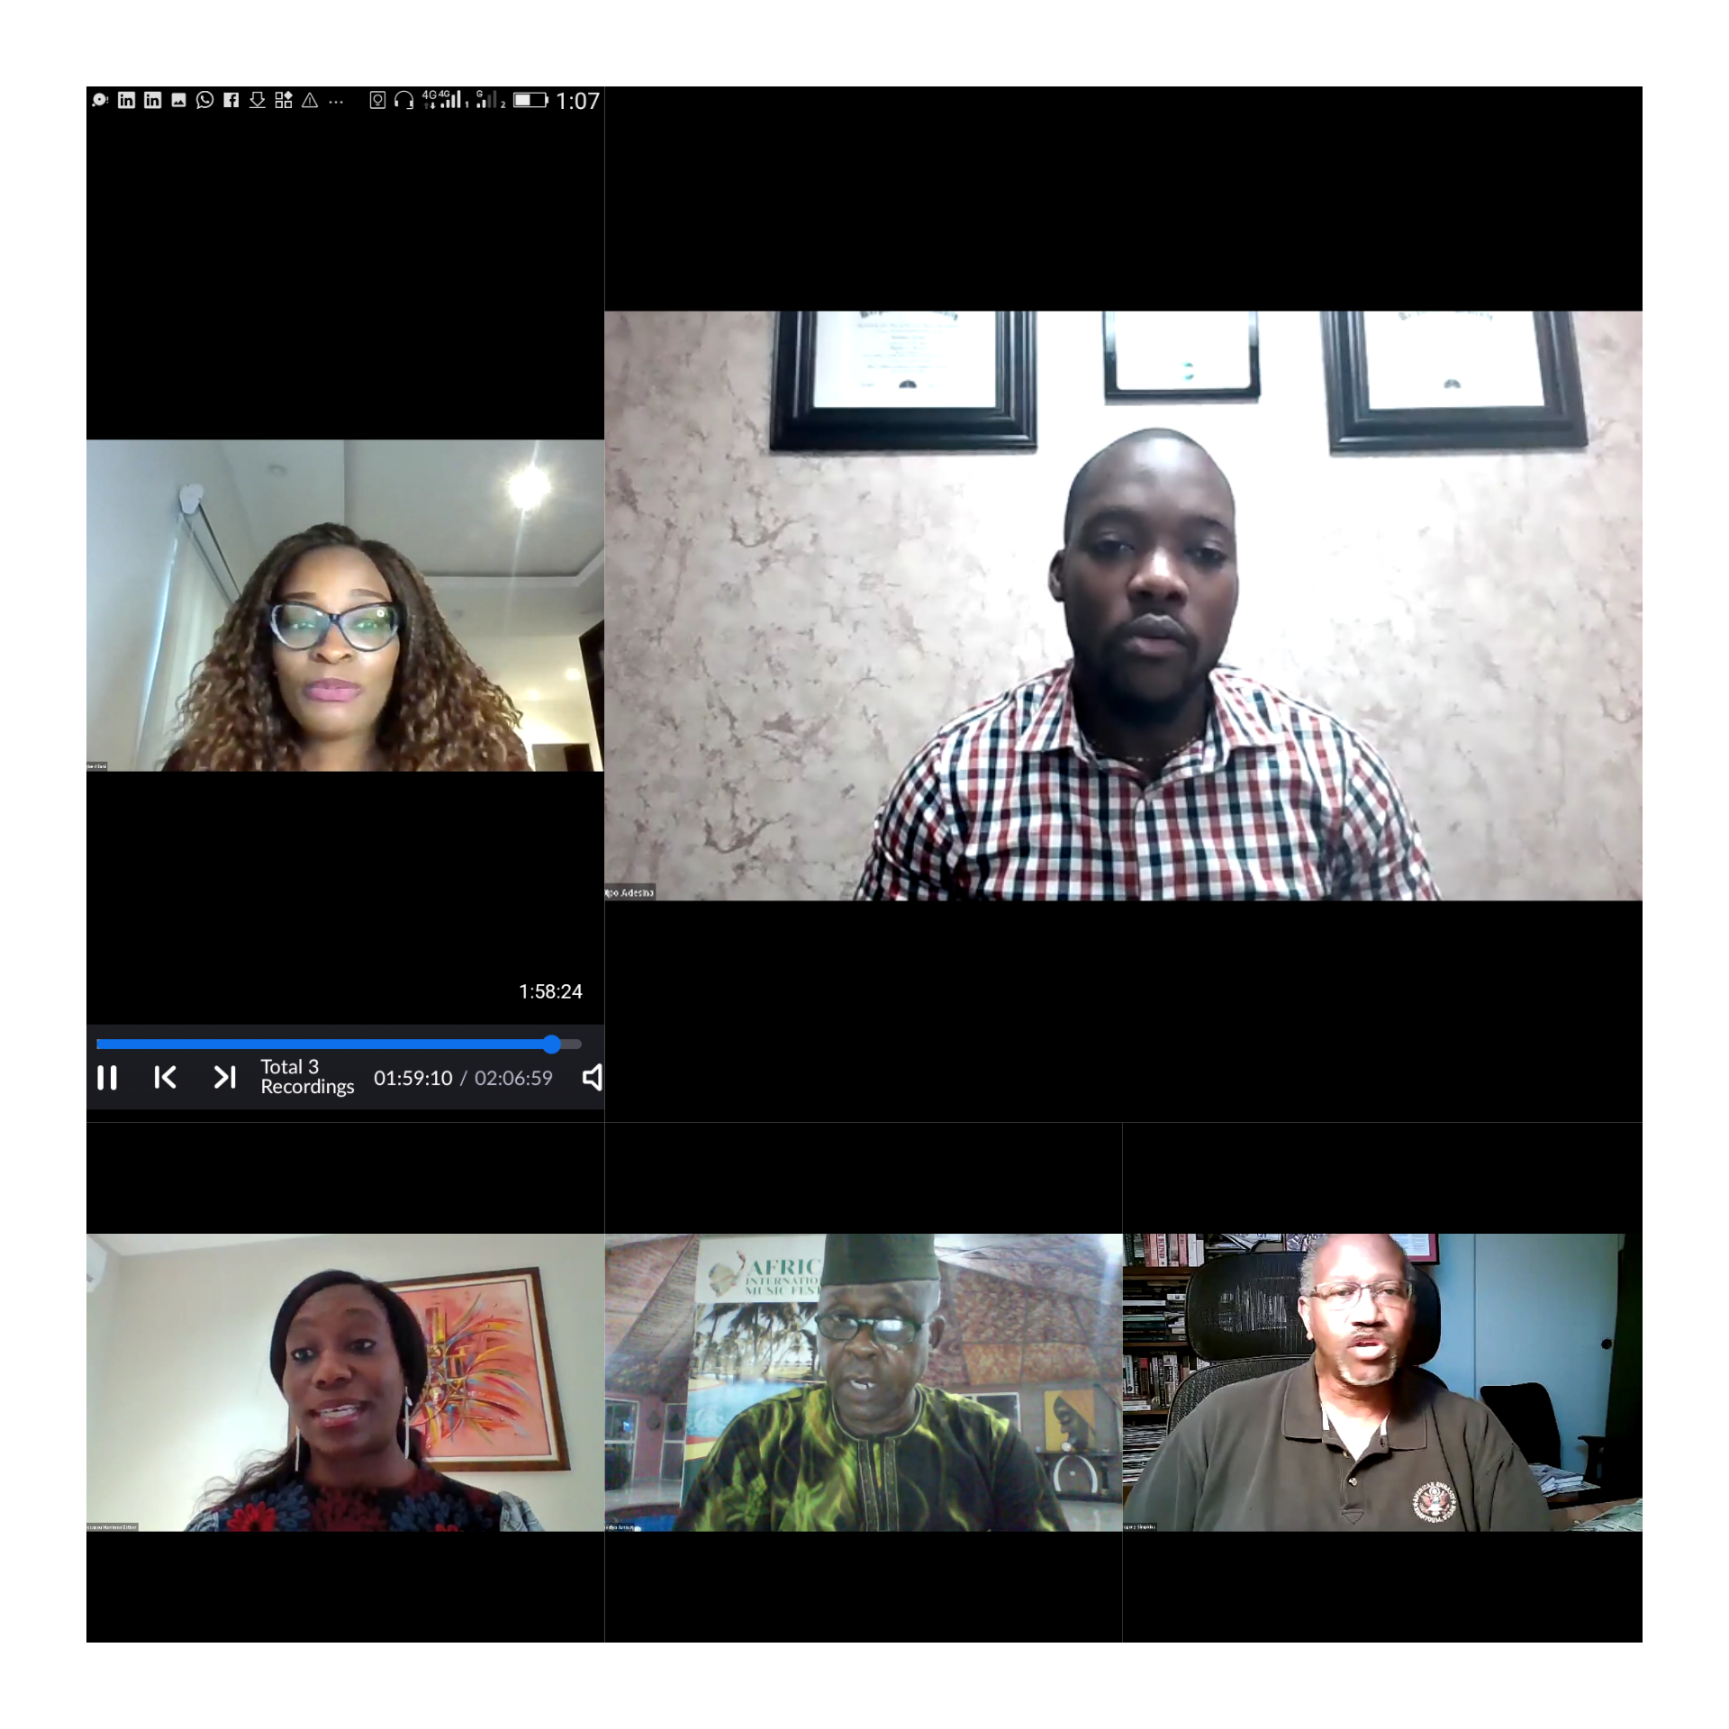
L-R Rolake Akinugbe-Filani, Dipo Adesina, Esther Dassanou, Dr. Olawanle Akinboboye and Gregory Simpkins

The discussion centered on the importance of good government policies and how it affects the flow of business transactions. Each speaker shared their thoughts on the question asked - 'Is Africa still a choice destination for doing business?'
Esther Dassanou highlighted the fact that Africa has the largest percentage of women entrepreneurs and business owners and she believes Africa is still a choice destination for doing business with opportunities, waiting to be explored.
Dipo Adesina, a serial entrepreneur envisaged the population strength of Africa (which is 1.2 billion people) as a pointer that Africa is still a choice destination for business. He also mentioned that entrepreneurs must continue to look at which continent is constantly growing in population so as to understand where to invest.
Dr. Akinboboye, a business leader in the tourism industry took a step by step approach to highlight the fact that Africa has a 30.2 million square kilometer area with a population of 1.2 billion people.He made his point clear that with all Africa has, Africa is still a choice destination for doing business.
Gregory Simpkins also shared insights on the goal of AGOA to increase Intra-Africa trade, and connect business people together. He mentioned that one of the benefits was the creation of scale.
In between the panelists were standalone global impact thought leaders and influencers such as Dr Arikana Chihombori-Quao , Max Sutherland and Delegate Darryl Barnes who spoke and moved people to action.
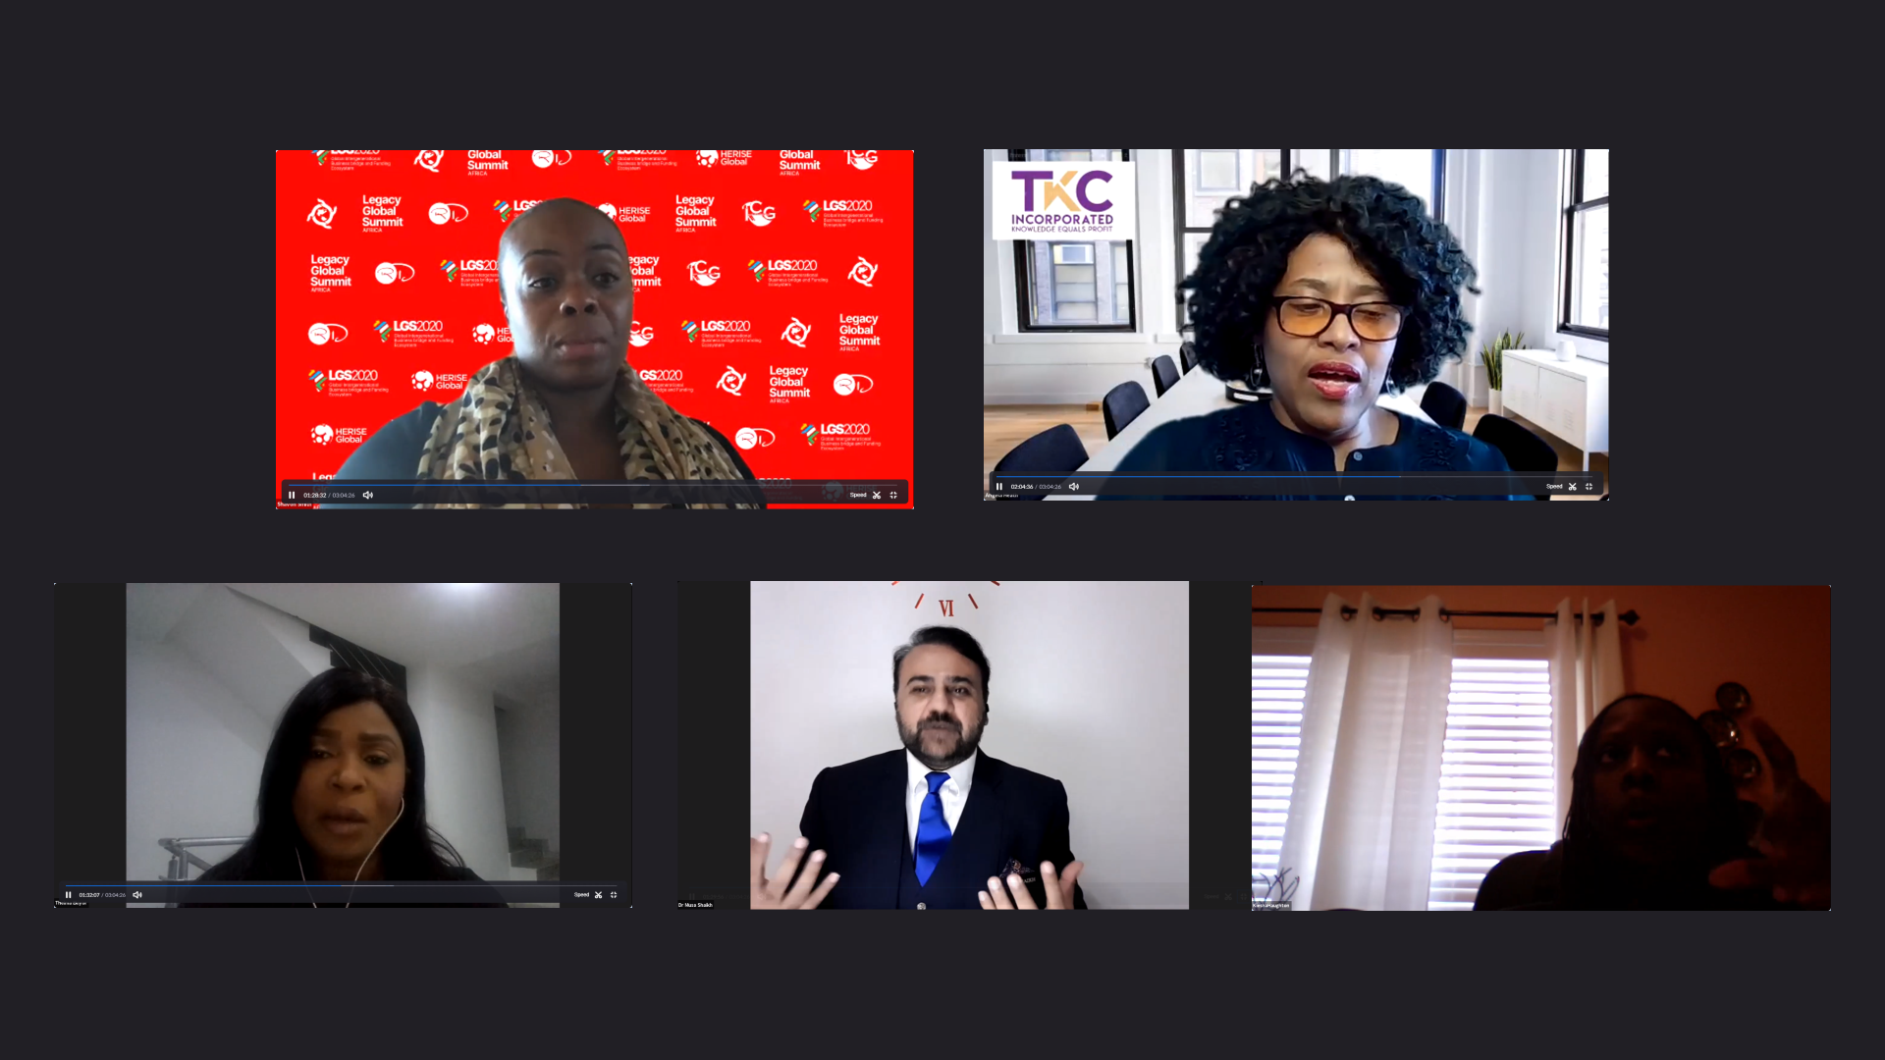
The “Public-private-partnership: A Fundamental Key To Developmental Growth” panel session engaged participants and co-speakers on the wide range of discussions, from international public-private partnerships to foreign investments in the African continent. Moderated by Shavon Smith, Principal, the SJS Law Firm, the session was an eye-opener to foreign partnerships and global business opportunities available for African business owners, as well as possible limitations. The panelist drove their points home by highlighting a few key factors influencing the Public-private-partnership ecosystem globally, amongst which are local and international policies, leadership, market accessibility, local talent and public perception
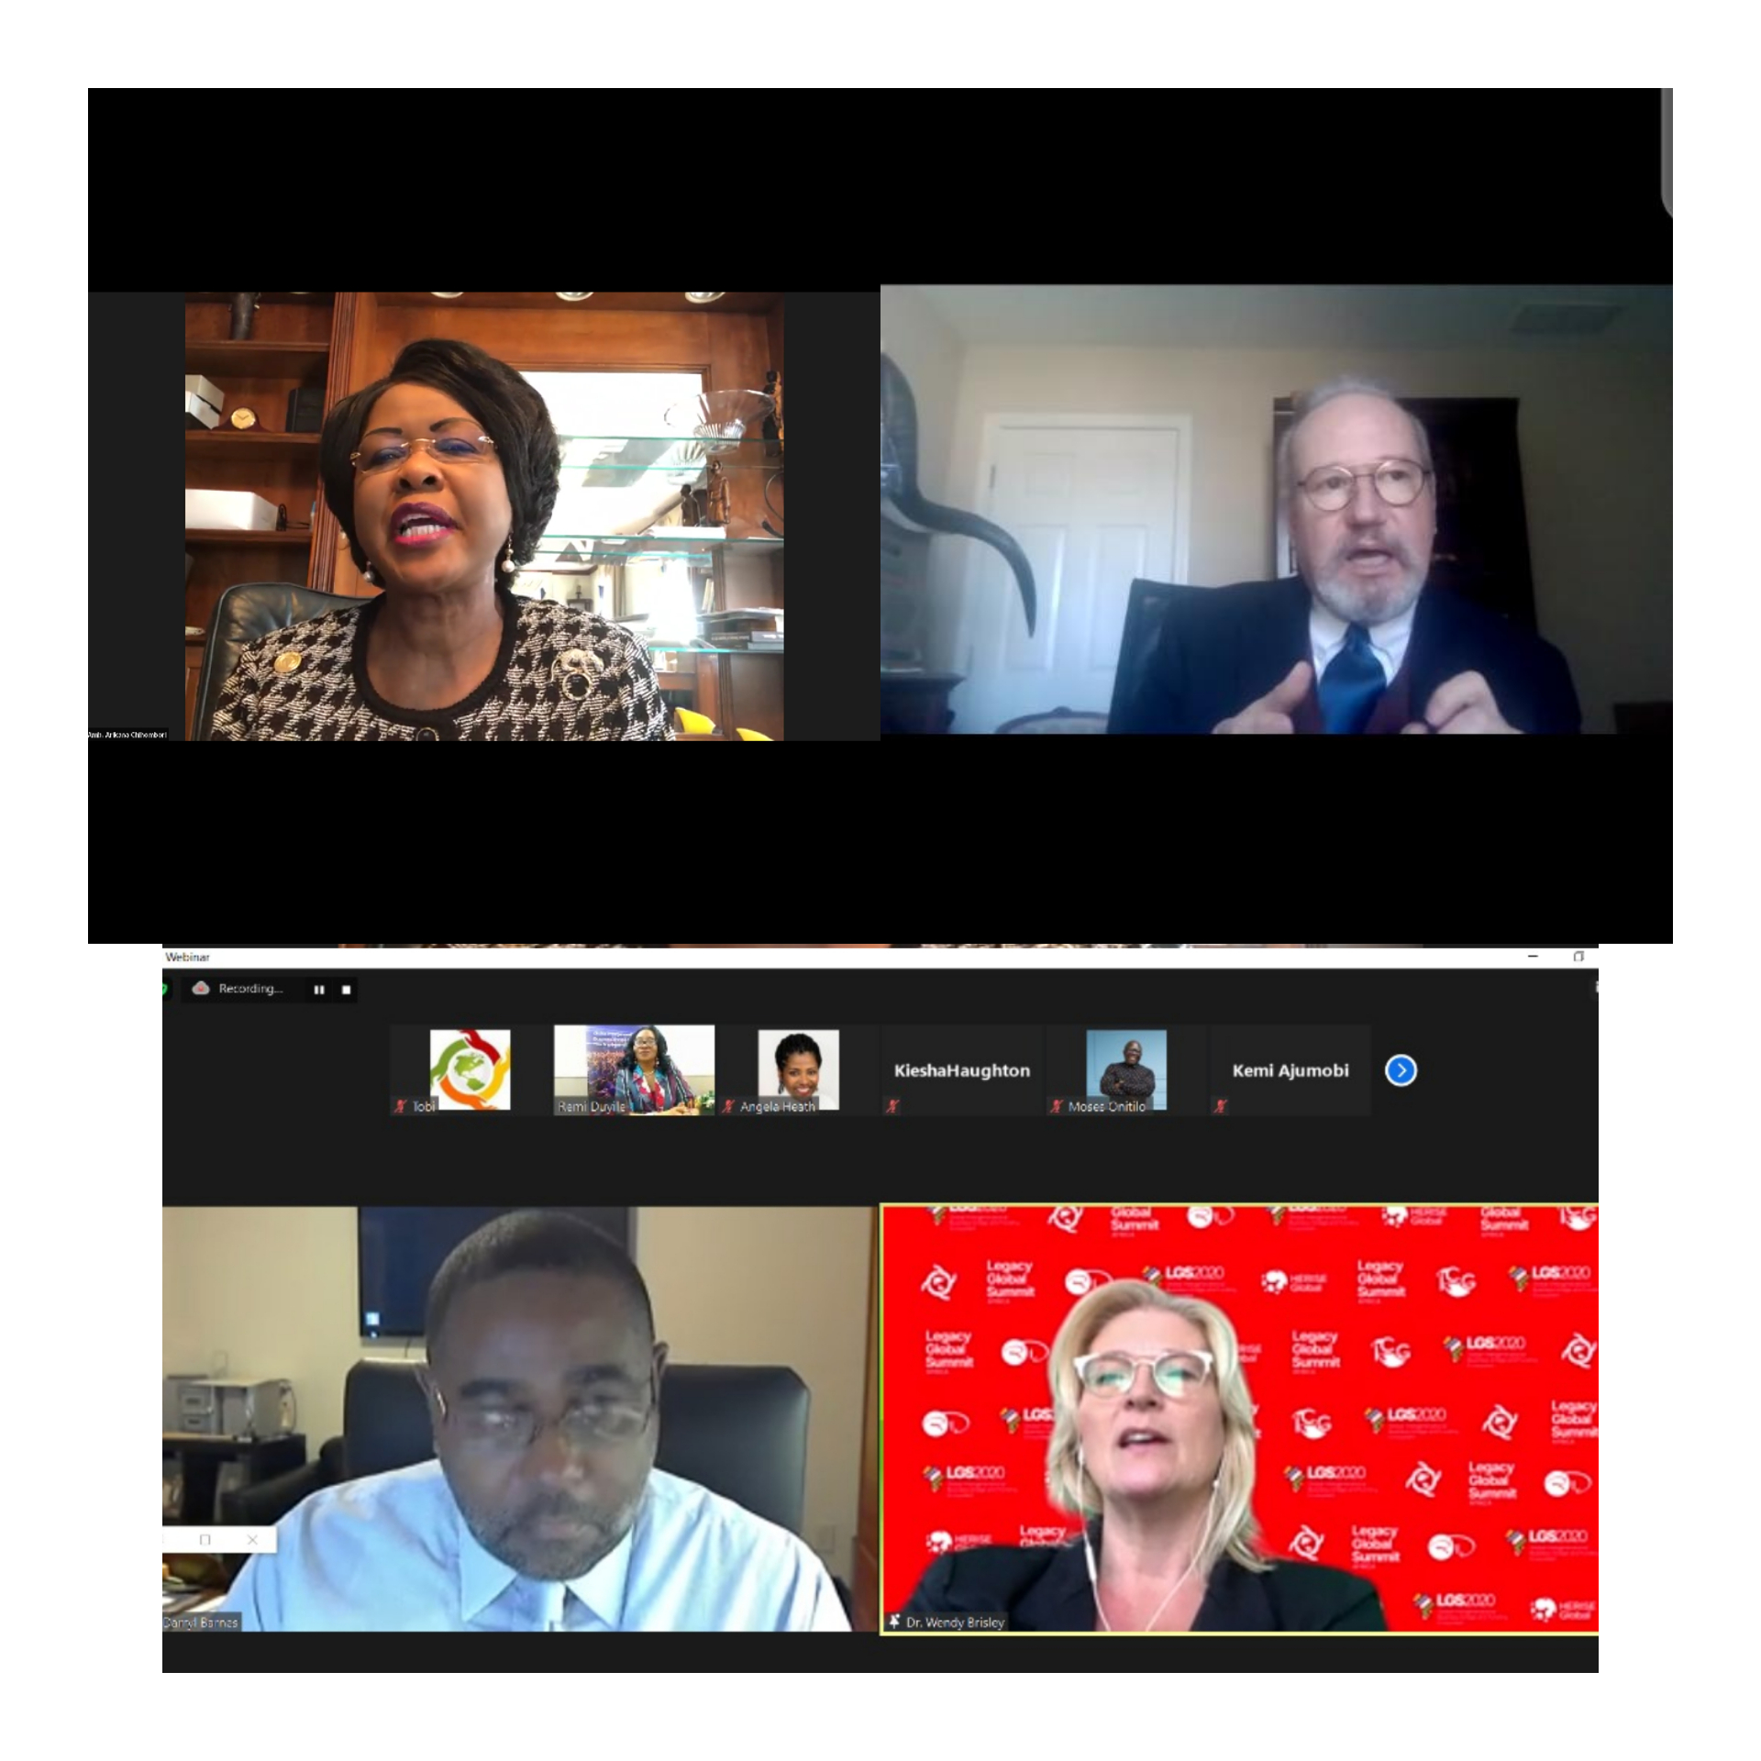
L-R Dr. Arikana Chihombori-Quap, Max Sutherland, Darryl Barnes and Dr. Wendy Brisley

Special remarks were also made by the State Attorney for Prince George’s County, Aisha N. Braveboy, the U.S. Representative for Maryland’s 4th Congressional District, Congressman Anthony Brown and Honorable Darryl Barnes, the Representative of the 25th Legislative District in the Maryland House of Delegates.

Friday, 6th November 2020
The second day of the event kicked off with a presentation on 'Sustainable Ecosystem for African businesses' by Guest Speaker Otunba Bimbola Ashiru, former Commissioner of Commerce and Industry and Director of O’DUA Investment Company Limited
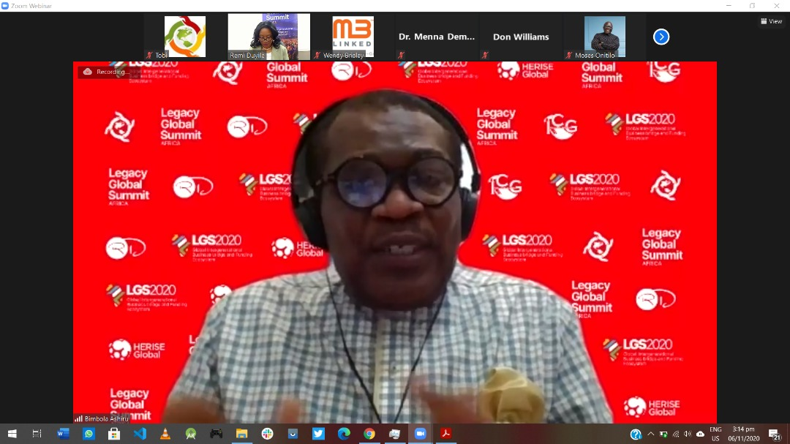
Otunba Bimbola Ashiru

He highlighted the potentials of the African market and laid emphasis on the fact that Africa is recognized as the next business hub waiting to be harnessed. "A bright light shines on the African tech ecosystem" said Otunba Bimbola.
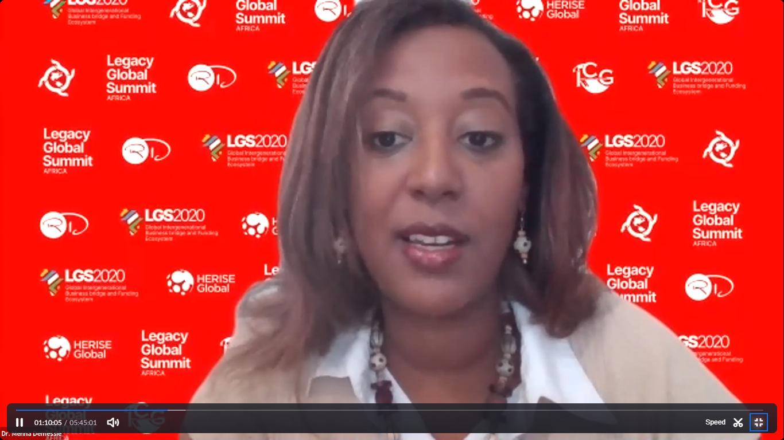
Dr Menna Demmesie
The event continued with a Guest session anchored by as Dr Menna Demessie who spoke on the topic “Leveraging Policy and Policymakers for International Trade Relations”. Dr Menna extensively impressed the need for business owners, particularly the locals to get accustomed to the policies and laws - local, state, federal and international - that would help facilitate ease of doing business.
Hon. Aisha Braveboy
Honorable Aisha Braveboy, earlier in the event, gave a special remark acknowledging the great work done by Dr Remi Duyile, the convener of the program. She expressed in joy in the vision of the Summit, wholeheartedly, and appreciated the Speakers and participants who availed themselves on that day. Honorable Aisha also anchored the graduation ceremony of the HERISE Global Internship program.

The first panel for the day come up shortly after Dr Menna’s session. Tagged “Going Global: Understanding International Trade and Development,” the session featured Global thought leaders from various works of life namely; Tisa Clark, President, J.D. Clark Professional Services, L.L.C. (JD Clark); Don Williams, President and CEO of Princeton Healthcare International; Dr Kamaladevi Baskaran, Head of Industry Relations & Faculty, Department of Management & Commerce, Amity University, Dubai; Denise Cortês-Keyser, Entrepreneur, Motivational speaker, Finance and Investments Adviser Founder, DCK GLOBAL. Dr Kavita Kapur, an Assistant Professor at the College of Business, Bowie State University moderated the session.

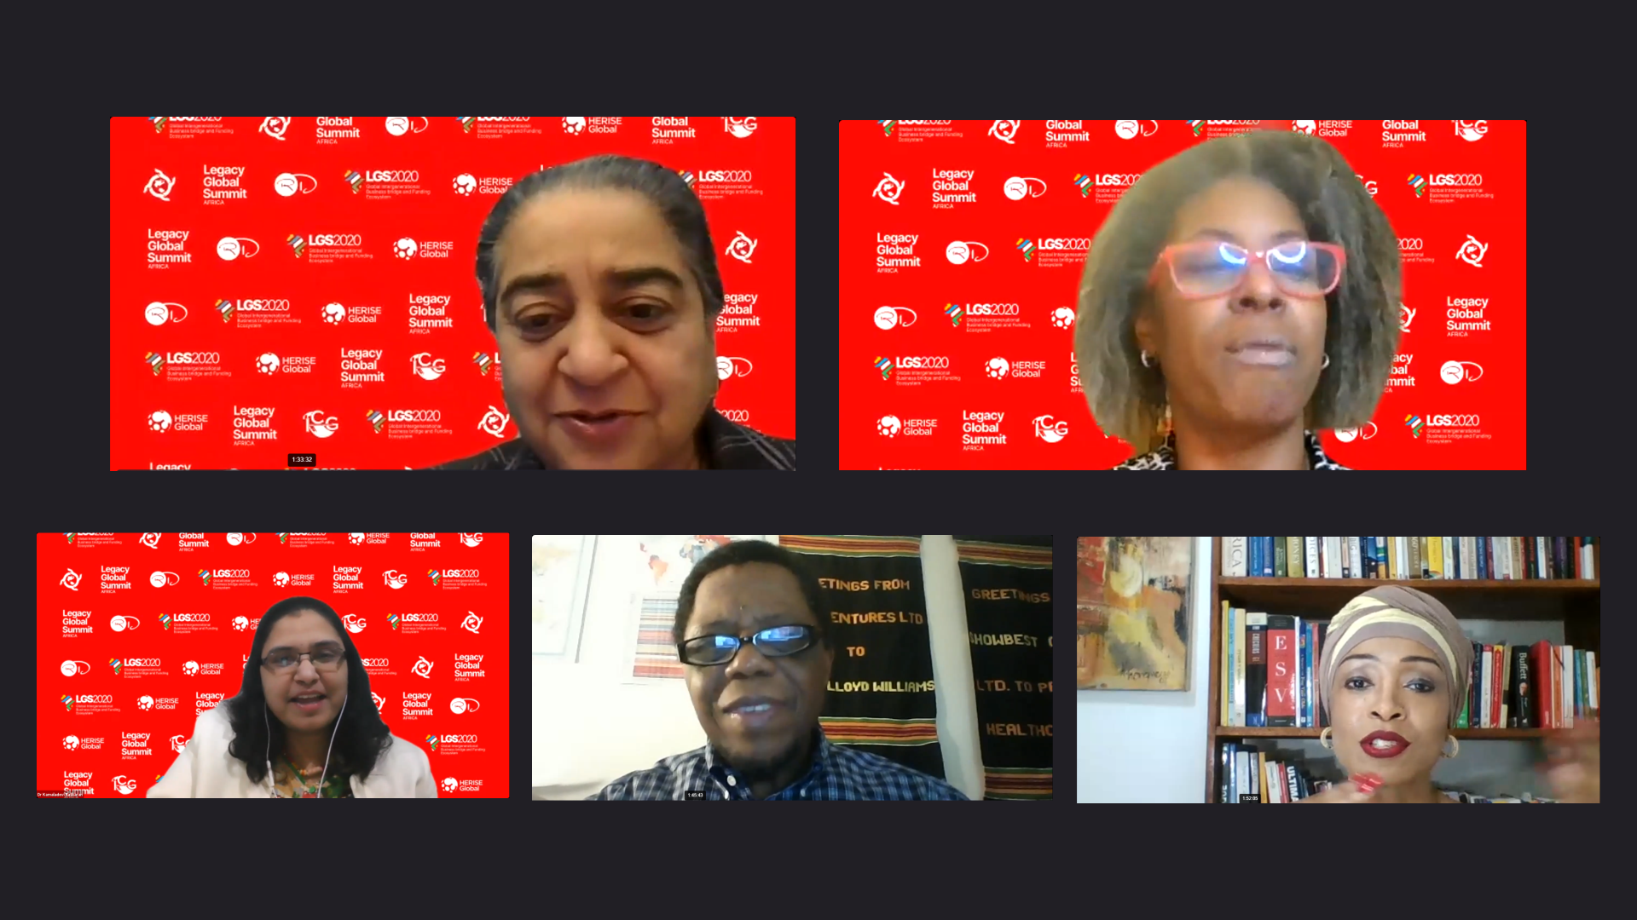
A cross section of the panelists
The panel discussions was deeply engaging, as conversations centered on cross-disciplinary collaborations and partnerships, exploring global talent exchange, international trade processes and attracting the right investments/investors.
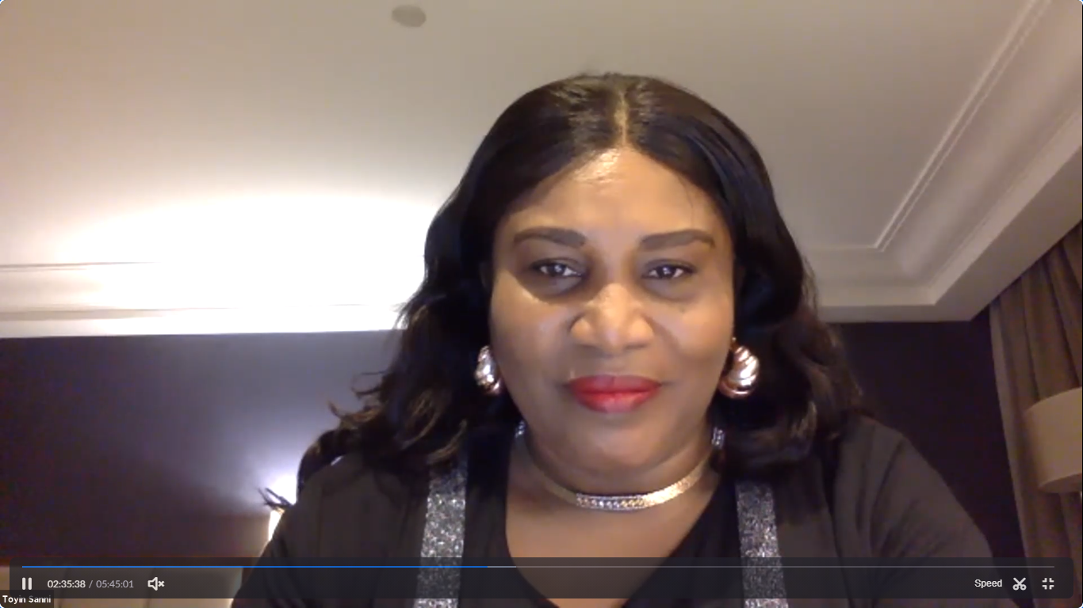
Mrs Toyin Sanni

Mrs Toyin Sanni, CEO, Emerging Africa Capital spoke on the “Women Empowerment through Trade and Investment” She approached the topic keenly from her experience as a Financial Markets Expert and Gender Leader. Mrs Toyin, during her session, highlighted the importance of creating opportunities for women, as they are responsible to many grass root business establishments on the African continent. She went further to propose key solutions that could help promote gender empowerment and parity across the continent. Education, easy access to funding, and promotion of gender equality were some of the key solutions she mentioned, with the promotion of gender equality on the very top of that list.

Afterwards, Denise Cortês-Keyser gave an expose on The African Union’s African Continental Free Trade Area (AfCFTA) uncovering key details on the scope of the agreement. She touched on historical data, the vision of the trade agreement which is to allow free access to commodities, goods, and services across the continent; and the current number of countries who have both signed and approved ratification of the AfCFTA Agreement – which currently stands at 30 countries, as at the time of her session. Denise stated 2 major issues posing as bulwarks to the AFCFTA. Issues such as unified trade policies and markets, cultural gaps, and manufacturing pose a great challenge to the implementation of the agreement. She further suggested seven namely: trade finance, trade facilitation, and trade policy, trade related infrastructure, trade information, productive capacities, and a factor market integration.
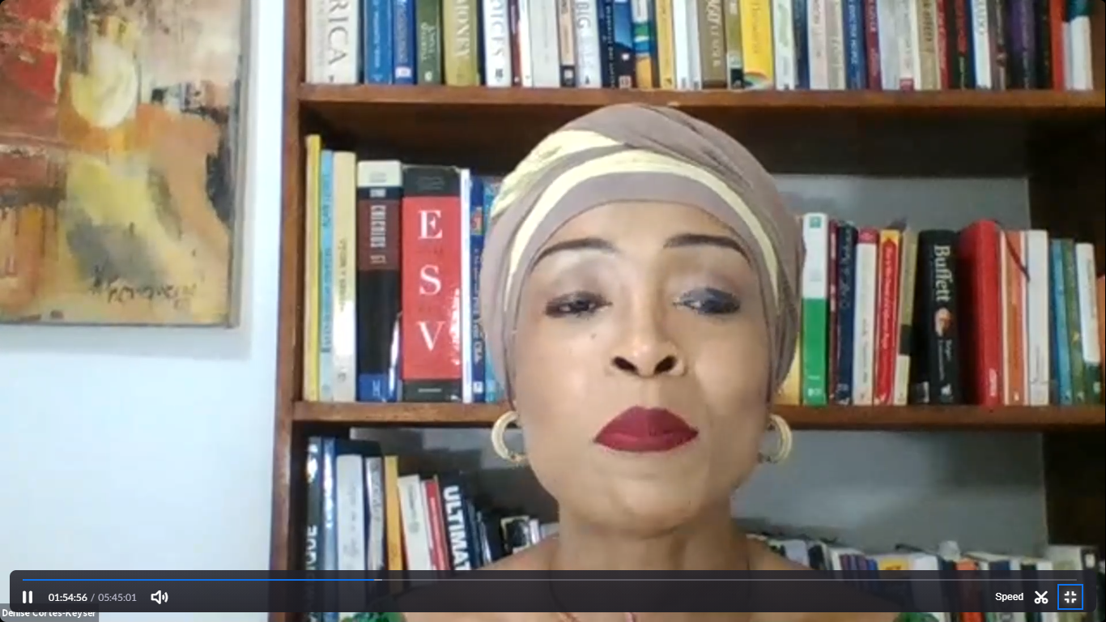
Denise Cortês-Keyser

Victory Oluwasegun, CIO of Jamborow and COO/Co-founder of SpringPort Technologies moderated the next panel session ‘Generational Bridge-Building for Emerging Leaders and Entrepreneurs’ with panel members: Josephine Agbeko, Dayo Israel and Lara Abiona.

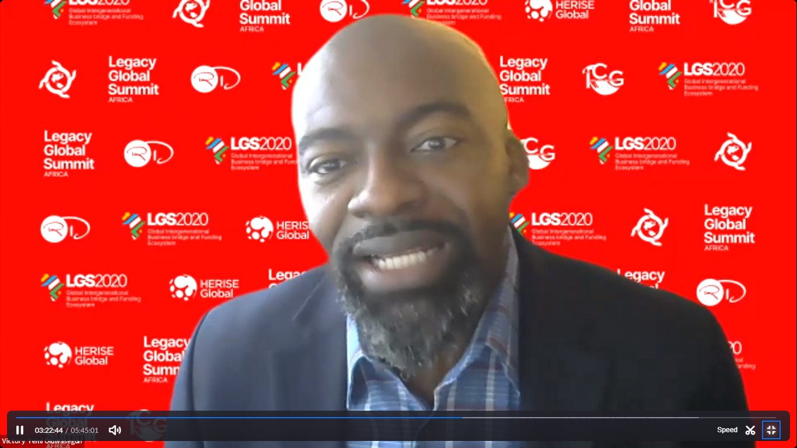

Victory Oluwasegun

They addressed critical issues that stand as barriers between different generations. They highlighted the fact that all generations have something to offer and more would be achieved if each generation can leverage their strengths, and collaborate instead of compete.
In response to a question on the challenges of intergenerational gap, Josephine Agbeko described the younger generation as a set of people who will always ask “why” and sometimes such characteristics might be in contrast with the perception and attitude of the older generation and vice versa. She affirmed the importance of collaboration between generations. Lara Abiona also affirmed that the younger generation are willing to provide answers for their future. Victory Oluwasegun chimed in with the phrase 'In the long run it's not what we do that matters but why'.

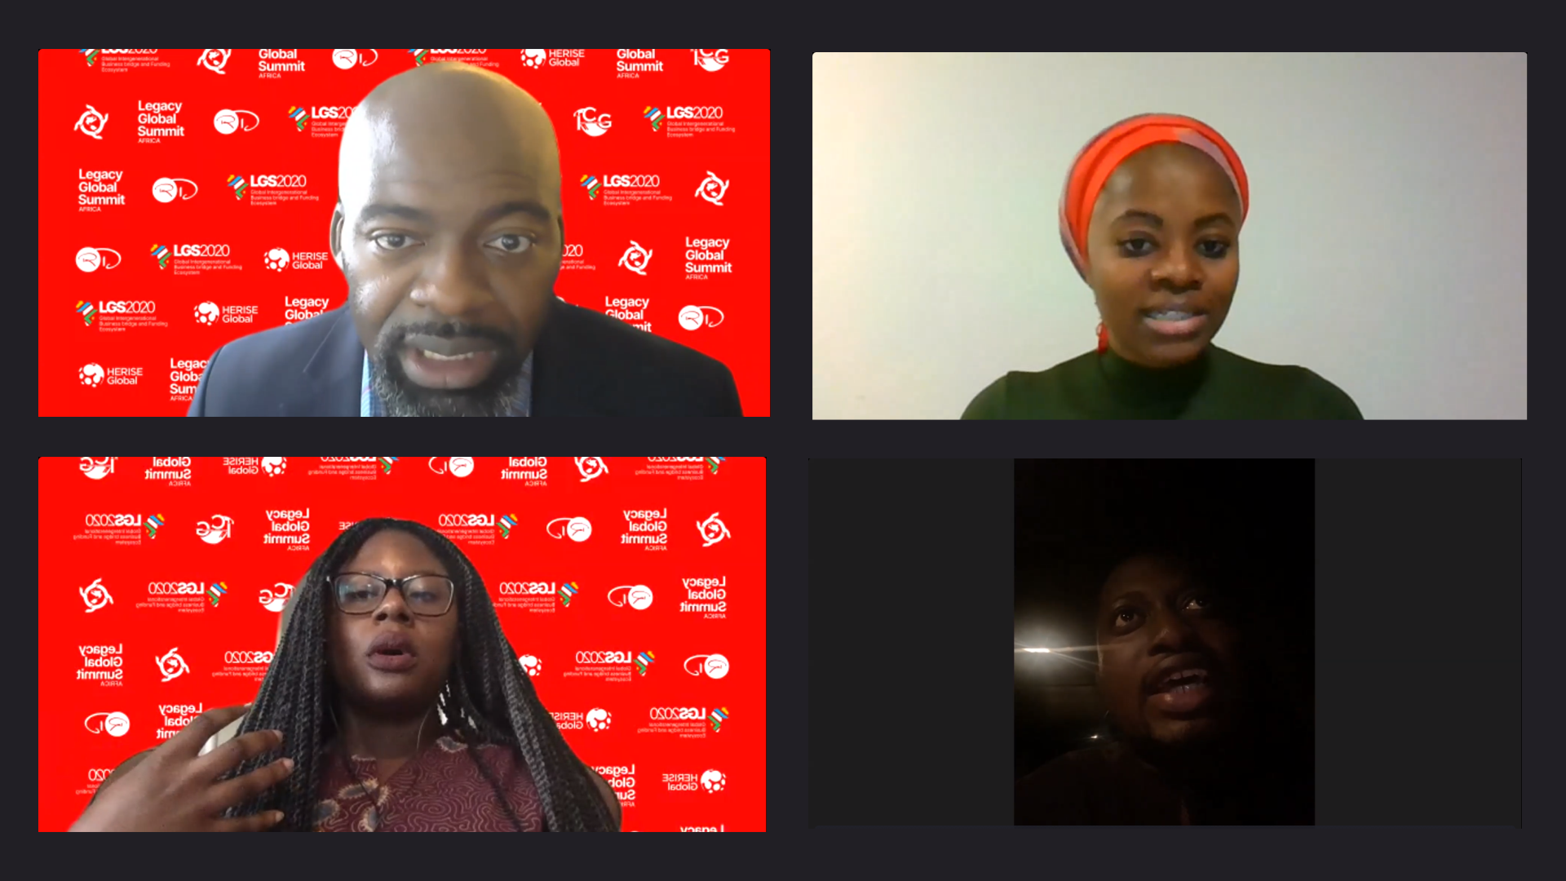

Top (L-R): Victory Oluwasegun, Victory Oluwasegun, CIO of Jamborow and COO/Co-founder of SpringPort Technologies; Josephine Agbeko, Climate justice and Sustainable Business Development Professional
Bottom (L-R): Lara Abiona, Director of Partnerships and Advancement, Baobab Consulting; Dayo Israel, Permanent Board Member at Lagos State Universal Basic Education

The ‘Diplomatic Round table session’ followed immediately, anchored by Dr. Lawrence Mcneil the Dean of Bowie University. The panel members were Lawrence Manzi, Amb. Pradeep K Kapur, and Kayode Alabi.

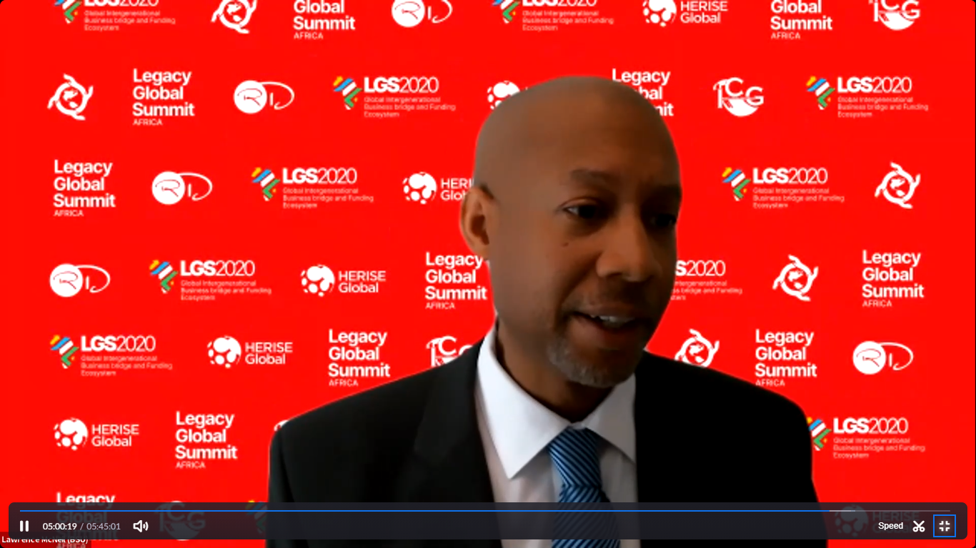

Dr Lawrence McNeil

Amb. Kapur, while speaking on trade and investment stated the impact Africans in Diaspora can have on Africa if they decide to build and invest in Africa. He acknowledged the achievements of Africans in Diaspora in different sectors and suggested that it's important that Africans in Diaspora begin to create a legacy in Africa as their heritage.

Also Mr. Lawrence Manzi highlighted 3 pillars responsible for the growth of Rwanda - Unity as a people, Accountability and thinking big.

Mr. Kayode talked about the efforts made by the Kwara State Government in Nigeria as regards trade and investment in different sectors

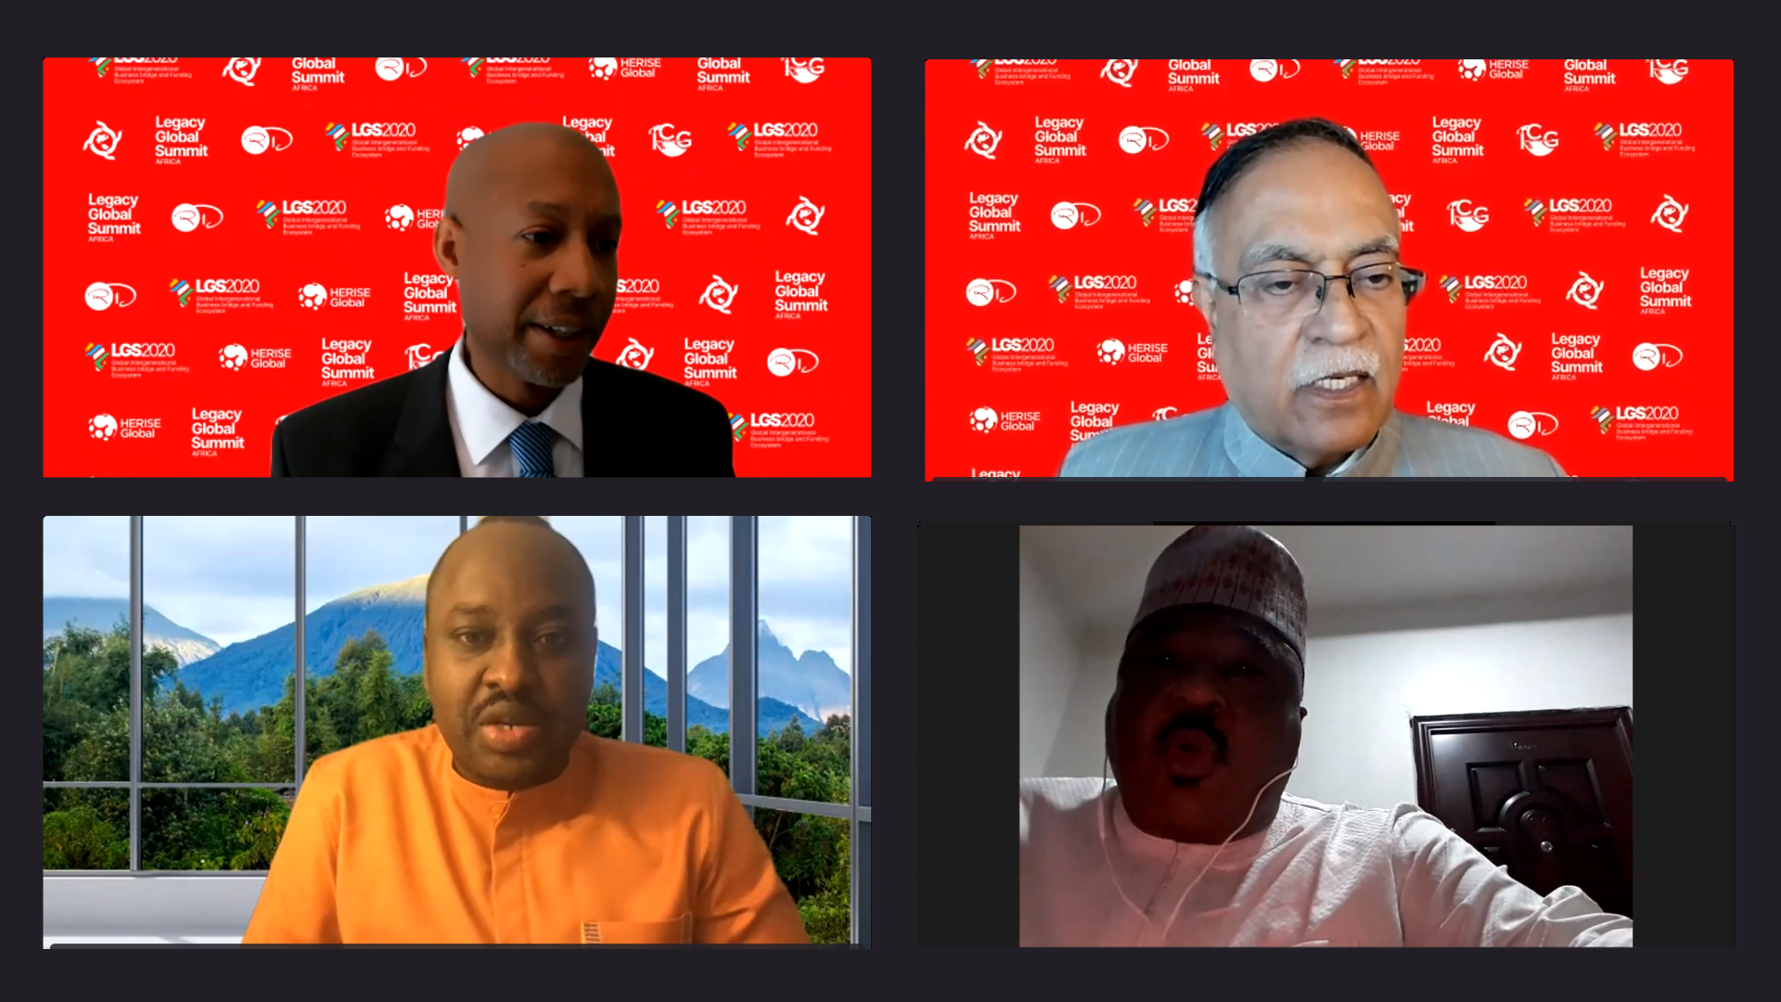

Top (L-R): Dr Lawrence Mcneil, Dean of School of business, Bowie State University; Ambassador Pradeep K Kapur, Ambassador of India to Chile and Cambodia;
Bottom (L-R): Lawrence Manzi, First Counselor in charge of Political Affairs at the Embassy of Rwanda; His Excellency Kayode Alabi, Deputy Governor, Kwara State, Nigeria

The last panel session was titled ‘Entertainment: Tool for Nation Building’. The session was moderated by Kemi Ajumobi with Rozina Negusei and Audi Maikori as panelists

During the session the successes and achievements of the entertainment industry in Africa and the global impact was highlighted.

Audu Maikori talked about how African content enjoys more streaming and downloads from international audiences.

Rozina Negusei also mentioned that African entertainment is now the best next thing after playing soccer drawing the attention of music lovers worldwide.

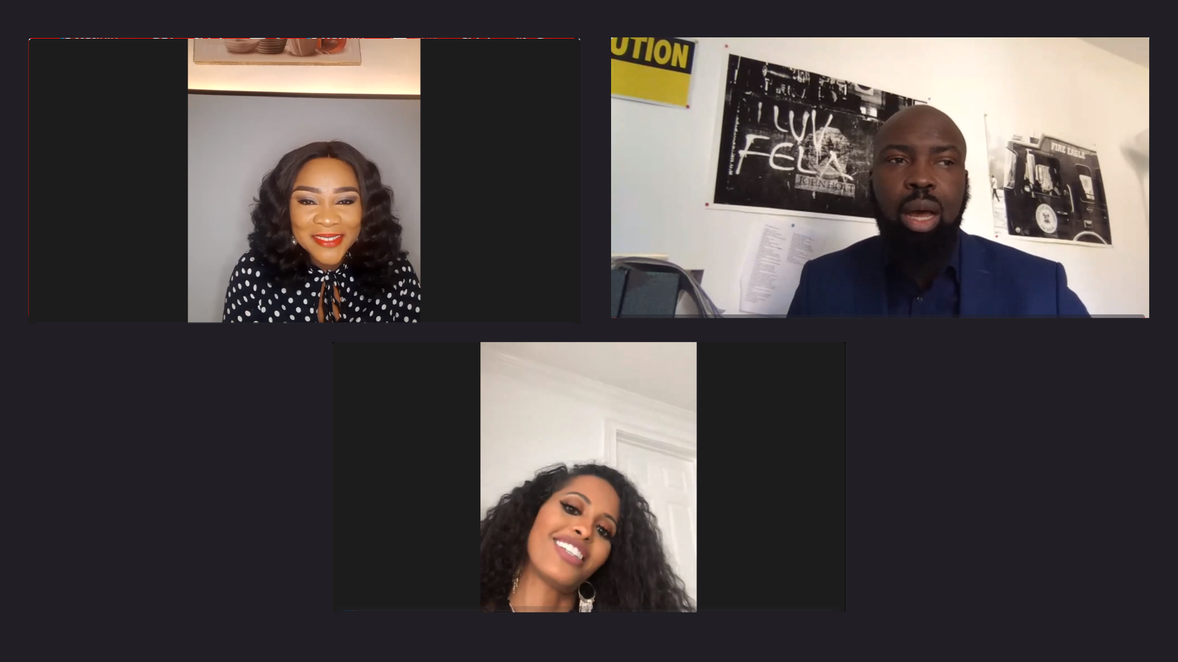

Top (L-R): Kemi Ajumobi, Associate Editor, Businessday Media Ltd.; Audu Maikori
Founder, Chocolate City Group
Bottom (L-R): Rozina Negusei, President and CEO Entreeg records Record label executive

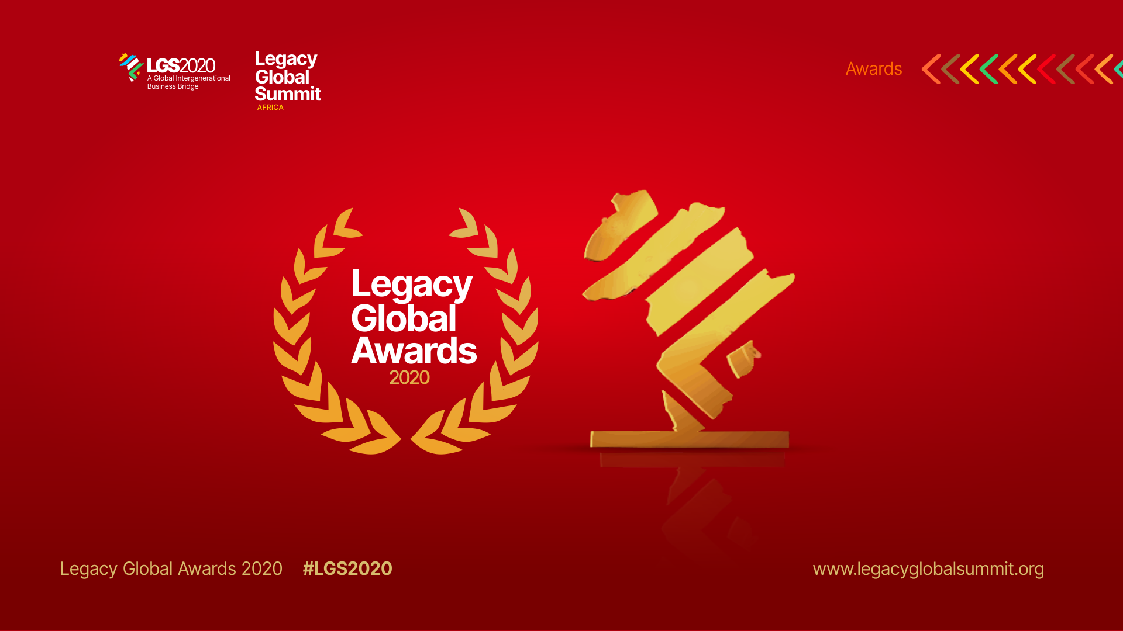

The two-day event ended with an Award session, launch of the 'Legacy Colossus Coaching for women and also the 'Legacy Global Network' - a platform to connect global entrepreneurs and business leaders that will serve as an engine of growth for emerging leaders.

Dr. Remi Duyile, the Convener giving the closing remarks.

The summit will ultimately impact business interactions between nations, creating a bridge for investors and entrepreneurs to meet and create innovative value. The 2021 edition is scheduled to hold in the UAE.
www.legacyglobalsummit.org
www.legacypremier.org
Press contact: Info@legacypremier.org
18006148061

